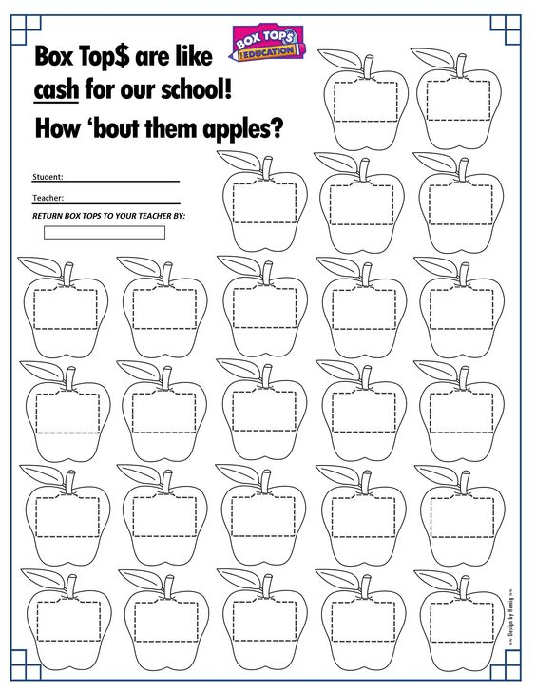

Directions: Please attach one box top to each apple and return to school on any  
**Wednesday** in September and your child will receive a prize.

Bonus: Check here if you signed up for Giant A+ Rewards

Check here if you signed up for eScrip